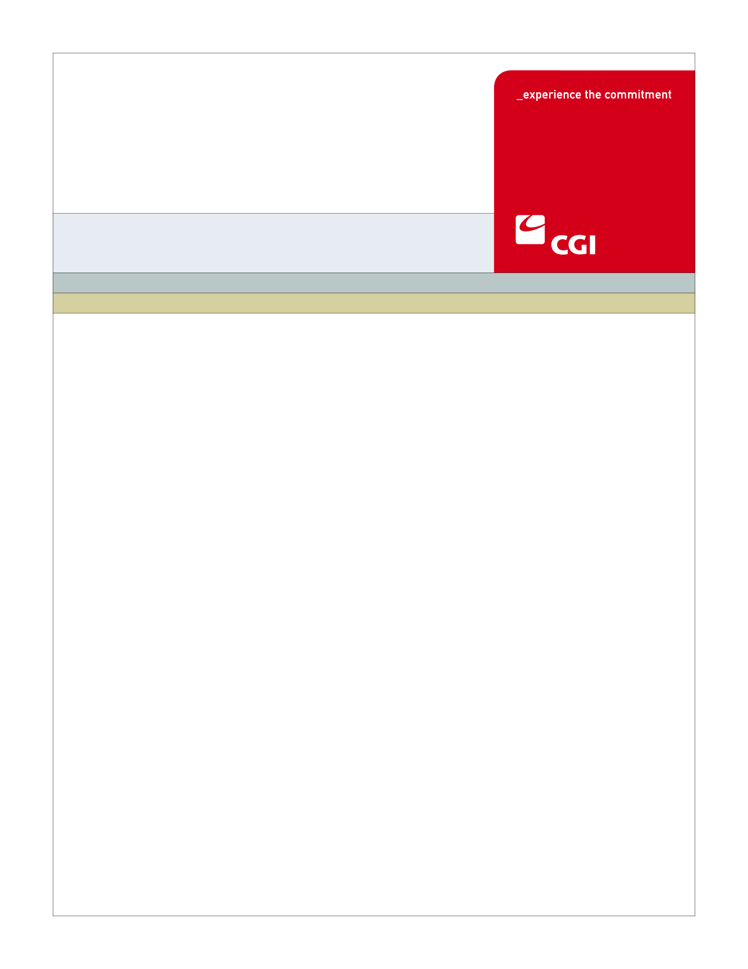USE

**SH-003**

**Manage Employee Roster**

**Use Case**

**Colorado Health Benefit Exchange (COHBE)**

**Version 2.0**

**November 16, 2012**

REVISION HISTORY

|  |  |  |  |
| --- | --- | --- | --- |
| Version | Date | Modified By | Description |
| 0.1 | 10/15/2012 | Derek Sullivan | Initial Draft |
| 0.2 | 10/23/2012 | Derek Sullivan | Discovery Session Updates |
| 0.3 | 10/31/2012 | Derek Sullivan | Elaboration Session Updates |
| 1.0 | 11/07/2012 | Derek Sullivan | BPM Updates |
| 1.1 | 11/09/2012 | Derek Sullivan | Verification Updates |
| 2.0 | 11/16/2012 | Derek Sullivan | Approved Version |
|  |  |  |  |
|  |  |  |  |
|  |  |  |  |
|  |  |  |  |
|  |  |  |  |
|  |  |  |  |
|  |  |  |  |
|  |  |  |  |

TABLE OF CONTENTS

1 Use Case: Manage Employee Roster 6

1.1 Goal 6

1.2 Brief Description 6

1.3 Requirements Traceability 6

1.4 Primary Actor 7

1.4.1 Employer 7

1.4.2 Broker 7

1.4.3 Back Office 7

1.5 Secondary Actor 8

1.5.1 Service Rep 8

1.5.2 Exchange 8

1.5.3 Employee 8

1.5.4 Carriers 8

1.6 Pre-Conditions 8

1.7 Successful Post-Conditions 8

1.8 Triggers 8

1.9 Assumptions 9

2 Flow of Events 10

2.1 Basic (Main) Flow – Add Employee to Roster 10

2.1.1 View Employee Roster 10

2.1.2 Add Employee to Roster/Coverage Availability? 11

2.1.3 Enter/Upload Employee to be Added to Coverage 11

2.1.4 Is Employee Roster Data Complete? 11

2.1.5 Add Employee to Roster/Coverage Availability 11

2.1.6 Is Non-Annual Enrollment Period Required for Employee? 11

2.1.7 Next Steps 11

3 Alternate Flows 12

3.1 Remove Employee from Coverage 12

3.1.1 Remove Employee From Coverage? 12

3.1.2 Enter/Upload Employee to Be Removed From Coverage 12

3.1.3 End Coverage Availability 12

3.1.4 Is Employee Enrolled in Employer Plan? 12

3.1.5 Update Billing Data 12

3.1.6 Send Removal from Coverage Notification 12

3.1.7 Receives Notification of Removal from Coverage 12

3.1.8 Dis-Enroll Employee 13

3.1.9 Update Enrollment Information 13

3.1.10 Receive Enrollment/Disenrollment Information 13

3.1.11 Receives Notification of Removal from Plan 13

3.2 Participate in SHOP Enrollment Period 13

3.2.1 Participate in SHOP Enrollment Use Case 13

4 Exception Flows 14

4.1 14

5 Specifications 15

5.1 Business Rules 15

5.1.1 Add Employee to Roster 15

5.1.2 Remove Employee from Coverage 15

5.1.3 Update Billing Data 16

5.2 Process Rules 16

5.2.1 Complete Roster Data Fields 16

5.2.2 Non-Annual Enrollment 16

5.2.3 Employee Enrollment 16

5.3 Workflow 16

5.3.1 Worklist Definitions 16

5.4 UI Screen Details 17

5.4.1 UI Flow Considerations 17

5.4.2 Employee Details 17

5.5 Communications 17

5.5.1 Imaging Requirements 17

5.5.2 Form Requirements 17

5.5.3 Notice Requirements 18

5.5.4 Other Communication Requirements 18

5.6 Interfaces 18

5.7 Reporting 18

5.7.1 User Experience 18

5.7.2 Business Activity 18

5.7.3 Workflow 18

5.8 User Security 19

5.8.1 Actor Status Changes 19

5.8.2 Sensitive Information/Data 19

5.8.3 Data Transmission Requirements 19

5.9 Activity Log and Audit Trail 19

5.10 Data Elements 20

6 Future Release Notes 20

Appendix A - Glossary 20

# Use Case: Manage Employee Roster

## Goal

The goal of this Use Case is to give the Employer the capability to upload and manage their Employee roster.

This Use Case completes succesfully when the Employer has uploaded their Employee roster and can begin shopping for plans.

## Brief Description

The Employer will provide information via manual entry or upload for each of the Employer's Employees and family members for which the employer offers coverage.

## Requirements Traceability

The following requirements are covered within this Use Case:

* GF076: Service Representatives will be able to perform all of the activities of the System on behalf of Customers, should Customers need assistance or not have access to the System. Activities of Service Representatives will be limited to the functions required by their roles.
* SH042: The employer will have self-service features accessible through the SHOP system that allows for management and maintenance of employees covered, enrollment periods, health plans offered to employees, employer contribution amounts/rates, and aggregated premium payment.
* SH046: The System will insure that employers will be able to see only employee data required to perform the functions of the solution. The System shall conform to HIPAA privacy and security standards.
* SH050: The small employer will need to provide the Exchange with enough information including number of employees and their family composition, employees' zip codes and dates of birth to enable the System to retrieve health plans that are available within the small employer employee’s coverage area during application completion.
* SH052: The System will enable employers to submit their employee information through standard Website methods including a simple web form and a CSV or Excel file upload to the Exchange. Additional submission methods, including mail or fax, will be available and provided by the Exchange if requested by the employer.
* SH059: The System will enable the employer to manage the employee roster to communicate which employees are still actively being covered by the small employer for healthcare.
* SH061: The SHOP Exchange shall allow Employers to define the start date for coverage for new employees. The coverage start date may be always a set number of days from employee start date or defined for each employee.
* SH067: When an employer adds a new employee, that employee will be notified by the Exchange via email that the employee can access the Exchange and enroll in an available health plan. New employees will be able to shop and enroll after their employer has added their information to the employee roster in the small employer profile section. The employee will have a special enrollment period that will be defined by Colorado's SHOP regulations or other government requirements.
* SH082: When an employer removes an employee from its employee list, the System will send a notification to the Carrier that the covered employee is no longer employed by the employer who is paying the health plan premium and a subsequent message to the Consumer that the Consumer’s coverage with the employer sponsored plan is expiring and the Consumer will need to visit the Exchange to update the employee’s information and select a new plan.
* SH084: The System will allow employers to define the effective date of the termination of coverage for employees.
* SH127: Brokers should be allowed to access and perform similar tasks that Employers are allowed to do in the Exchange.
* SH129: The SHOP System should provide the ability to distinguish between date of hire and effective date of coverage.

## Primary Actor

### Employer

The Employer can add or delete Employees from the Employee roster.

### Broker

A Broker performs activities for the Manage Employee Roster Use Case on behalf of the Employer, unless explicitly stated otherwise in this Use Case.

### Back Office

The Back Office performs activities for the Manage Employee Roster Use Case on behalf of the Employer if the Employer sends in their Employee roster by mail or fax.

## Secondary Actor

### Service Rep

Service Representatives can assist the customer at any point in the Manage Employee Roster process.

### Exchange

The Exchange will verify and store Employee roster data as well as send notifications to all parties involved for the addition and deletion of employee data to the Employee roster.

### Employee

The Employee will receive notifications from the Exchange notifying them of their coverage status.

### Carriers

After the Carrier receives notification of Employees being removed from the Employee roster they will dis-enroll the Employee and update enrollment information.

## Pre-Conditions

* The Determine Employer Eligibility Use Case must be successfully executed.

## Successful Post-Conditions

* The Employer has successfully updated their Employee roster and may begin shopping for plans.

## Triggers

* An Employer joins the exchange.
* The Employer hires a new Employee.
* An Employee no longer works for the Employer.
* An Employee’s employment category changes (full time to part time, part time to full time, etc.)

## Assumptions

* An Employee’s account on the Individual exchange is considered the master account of the Employee’s information and so takes precedence over Employee information maintained by the Employer in the Employer’s SHOP account.
* There needs to be education for employers/brokers on timing of termination of coverage for an employee through an update in the Employer’s roster and when the notice should be sent to the Employee. The obvious consideration is that we expect that the Employer will not want an Employee to receive a termination of coverage notice from the exchange prior to the Employer informing the employee of this termination, which may include a termination of employment.

# Flow of Events

The Business Process Activity diagram below shows the COHBE processes for the Manage Employee Roster Use Case. The steps numbered on the diagram below have detailed explanations in the sections that follow.



## Basic (Main) Flow – Add Employee to Roster

The Main Flow through this Use Case details the process of the Employer adding an Employee to the Employee Roster.

### View Employee Roster

The Employer views their profile on the SHOP system in order to manage and maintain their Employee roster.

### Add Employee to Roster/Coverage Availability?

The Employer chooses whether or not to add an Employee to the Employee roster or change an Employee on the roster from not eligible for employer sponsored coverage to eligible for employee sponsored coverage.

### Enter/Upload Employee to be Added to Coverage

The Employer will submit their Employee information to be added through a standard web form or via CSV or Excel file upload.

### Is Employee Roster Data Complete?

The Exchange will verify all required fields are complete (See Process Rule 5.2.1).

### Add Employee to Roster/Coverage Availability

The Exchange will add the Employee to the Employee roster or change an Employee on the roster from not eligible for employer sponsored coverage to eligible for employee sponsored coverage (See Business Rule 5.1.1).

### Is Non-Annual Enrollment Period Required for Employee?

The Exchange will verify the Employee as having a non-annual enrollment or not (See Process Rule 5.2.2).

### Next Steps

Based on information that was updated, user can proceed to various next steps, such as:

* Provide Payment
* Anonymous Shopping
* Select Plans and Set Contributions
* Create Account
* Participate in SHOP Enrollment Period

# Alternate Flows

## Remove Employee from Coverage

The Remove Employee from Coverage alternate flow details the steps taken by a user removing an Employee from coverage availability.

### Remove Employee From Coverage?

The Employer chooses whether or not to remove an Employee from coverage.

### Enter/Upload Employee to Be Removed From Coverage

The Employer will submit their Employee information to be removed through a standard web form or via CSV or Excel file upload.

### End Coverage Availability

The Exchange will end coverage availability to the Employee entered by the Employer (See Business Rule 5.1.2).

### Is Employee Enrolled in Employer Plan?

The Exchange will determine whether or not the Employee is currently enrolled in an Employer plan (See Process Rule 5.2.3).

### Update Billing Data

The Exchange will update the billing data to account for the change in Employee data (See Business Rule 5.1.3).

### Send Removal from Coverage Notification

The Exchange will send a removal from coverage notification on the Employer’s defined date of termination to the employee and the carrier providing coverage (See Section 5.5.3.1 and 5.5.3.2).

### Receives Notification of Removal from Coverage

The Carrier receives an Exchange initiated notification of the Employee being removed from coverage.

### Dis-Enroll Employee

After receiving the notification of removal from coverage the Carrier will Dis-enroll the employee from the covered plan.

### Update Enrollment Information

The Carrier will update the change in enrollment information.

### Receive Enrollment/Disenrollment Information

The Exchange will receive and store the updated enrollment/disenrollment information.

### Receives Notification of Removal from Plan

The Employee receives an Exchange initiated notification stating they are being removed from coverage.

## Participate in SHOP Enrollment Period

### Participate in SHOP Enrollment Use Case

This alternate flow will be handled in the Participate in SHOP Enrollment Period Use Case.

# Exception Flows

## 

There are no Exception Flows for the Manage Employee Roster Use Case.

# Specifications

## Business Rules

### Add Employee to Roster

Upon verifying the completion of all required fields (2.1.4), the Exchange will add the Employee to the Employee roster. The required fields include:

* Name (First, Middle, Last)
* Employee Code
* SSN
* Date of Birth
* Date of Hire
* Gender
* Working Hours/Day
* Annual Salary
* Class
* Preferred Method of Contact
* Employment Type (Full Time, Part Time, Temporary, Seasonal)
* Email
* Phone Number
* Address

### Remove Employee from Coverage

Once an Employer enters or uploads the Employee to be removed from coverage (3.1.2), the Exchange will end coverage availability for that Employee.

### Update Billing Data

After the Exchange has removed the Employee from coverage availability (3.1.3) and the Employee is enrolled in an Employer Plan (3.1.4), the Exchange will update the billing data to reflect the change in the Employee roster and proceed to the Provide Payment Use Case.

## Process Rules

### Complete Roster Data Fields

If the Exchange verifies that all required fields are complete, (Yes), proceed to Process Step 2.1.5.

If the Exchange determines that there are incomplete required fields, (No), return to Process Step 2.1.2 and enter required fields.

### Non-Annual Enrollment

If the Employer has had at least one enrollment period and the enrollment period is either closed or will be closed within 30 days (configurable) of the employee’s coverage start (Yes) then a non-annual “special” enrollment period is required, proceed to Alternate Flow 3.2.1.

Otherwise a non-annual “special” enrollment period is not required, proceed to Next Steps 2.1.7

### Employee Enrollment

If the Employee is currently enrolled in an Employer plan, (Yes), proceed to Process Step 3.1.5.

If the Employee is not enrolled in an Employer plan, (No), the process will end.

## Workflow

### Worklist Definitions

#### Employee Roster Worklist

* Task Name: Modify Employee Roster
* Worklist Name: Modify Employee Roster Worklist
* Task Type: Back Office Staff Normal Worklist
* Sort Criteria: FIFO by receipt into the Worklist
* SLA Watch: N/A
* SLA Warning: N/A
* Task Actions: Review Employee Roster for Modifications
  + Add? Delete?
  + If an Employee needs to be added to the roster, the Back Office will Enter or Upload the Employee to be added to the roster.
  + If an Employee needs to be deleted from the roster, the Back Office will Enter or Upload the Employee to be deleted from the roster.
* Comments: None

## UI Screen Details

### UI Flow Considerations

There are no UI Flow Considerations for the Manage Employee Roster Use Case.

### Employee Details

Modify “Add Employee Details” Screen:

* Remove Radio Buttons for Smoker (this is non-compliant with HIPAA and should not be visible to the Employer).

Modify “Edit Employee Details” Screen:

* Add text to Terminate Employee pop-up stating a termination notification will be sent to the Employee as soon as the OK Button is pressed.

## Communications

### Imaging Requirements

There are no Imaging requirements for the Manage Employee Roster.

### Form Requirements

Employers will be able to submit their Employee information through standard Website methods including a simple web form and a CSV or Excel file upload to the Exchange.

### Notice Requirements

#### Removal from Coverage Carrier Notification

When an Employer removes an Employee from its Employee list, the System will send a notification to the Carrier that the covered employee is no longer employed by the Employer who is paying the health plan premium (See Step 3.1.6).

#### Removal from Coverage Employee Notification

A notification to the Employee that the Employee’s coverage with the Employer sponsored plan is expiring and the Employee will need to visit the Exchange to update the Employee’s information and select a new plan. The notification will also include information on rights to continued coverage which include Colorado Continuation of Coverage and Cobra. This notice will be sent electronically and via mail (See Step 3.1.6).

### Other Communication Requirements

There are no Other Communication Requirements for the Manage Employee Roster Use case.

## Interfaces

There are no Interfaces for the Manage Employee Roster Use Case.

## Reporting

### User Experience

There are no User Experience Reporting Requirements for this Use Case.

### Business Activity

* Terminated employees and dates their COBRA notification was sent
* Roster auditing
* Chronological list of roster transactions
* Current census report (Employers and Brokers)

### Workflow

There are no Workflow Reporting Requirements for this Use Case.

## User Security

### Actor Status Changes

Business Associate agreements needed from Employer.

### Sensitive Information/Data

HIPAA compliance on web forms (do not display tobacco use to the employer).

### Data Transmission Requirements

There are no Data Transmission Requirements for this Use Case.

## Activity Log and Audit Trail

No updates captured at this time.

## Data Elements

There are no Data Elements for the Manage Employee Roster Use Case.

| Process Step Reference  **\*Required Field** | Field Name  **\*Required Field** | Required Field? | Action Taken | Actor Performing Action | Format, if known |
| --- | --- | --- | --- | --- | --- |
|  |  |  |  |  |  |

# Future Release Notes

There are no Future Release Notes at this time.

# Appendix A - Glossary

| Term | Definition |
| --- | --- |
| ***Activity Log*** | An “**Activity Log**” is a chronological record of every action taken by each user, and by the System on behalf of each user.  The activity log includes actions and events pertaining to transactions, workflow, security (including SIEM), Alerts, Notifications, Approvals and interactions between the user and the System such as submissions of forms, data and documents. |
| ***Alternative (process path)*** | An “alternative” is one subset of many steps within a process that achieve the same result or process end state. |
| ***Audit Trail*** | An “**Audit Trail**” is a subset of records in the Activity Log that are selected and correlated by criteria provided by the auditor or requesting authority. |
| ***Brokers*** | “Brokers” are persons certified to assist Employers and or Individuals in their activities to shop for insurance through the Exchanges. |
| ***Carriers*** | “Carriers” are providers of insurance who will sell Qualified Health Plans (QHPs) in the Exchange. Occasionally, the term Health Plans is used to mean Carriers. Where it is not clear if the term Health Plan means an offering of a Carrier or the Carrier itself, the context should be used to help clarify meaning. Carriers may also be referred to as “Issuers”. |
| ***Customer or Consumers*** | “Customers” or “Consumers” may be used interchangeably and are terms meant to define individuals or small employers or employees of small employers learning about opportunities to purchase, shopping to purchase, purchasing insurance through the Exchange, or modifying insurance purchased through the Exchange. References to Customers include, as appropriate, dependents of Customers, employees and dependents of employees and others covered by insurance purchased by Customers through the Exchange. |
| ***Employee*** | An “Employee” is a person who is employed by a company or small business who obtains insurance through the Exchange. |
| ***Employer*** | An “Employer” is a company or small business who participates in the Exchange to offer insurance and/or premium assistance to its Employee(s) or its Employee(s) and their dependents. |
| ***Exchange*** | During the implementation phase, the terms “Exchange” or “Exchanges” are meant to include technology, services, business processes, people, and other resources required to implement, operate and/or maintain the requirements or functions needed to support the ability for consumers to shop for and purchase health insurance. Specifically related to interpretation of a requirement, the term “Exchange” implies that the implementation of a requirement is not strictly limited to a technology solution.  • Individually, the term “Exchange” refers to each Exchange or both Exchanges as appropriate in the context.  • The Exchange is NOT a state agency but a standalone non-profit entity. It will serve as an aggregator of individual policies sold by private insurers and underwritten using the new federal and state underwriting and rating rules.  • The Small Business Health Options Program (SHOP) Exchange will support the specific needs of small employers.  • For context, the Exchanges will act much like an “Expedia or Orbitz for Health Insurance” system. They will allow individuals and small firms to obtain information, compare and purchase private health insurance plans. The Exchanges will also be the entities that will evaluate whether or not a particular insurance policy meets the criteria set out by the new federal rules for policies offered to individuals and small employers. |
| ***Form*** | A “Form” is a structured document or template that the Exchange uses to collect or distribute information. |
| ***Navigators*** | For the purposes of the implementation phase of the program, the term “Notification” or “Notices” shall mean a formal written document that is sent to Customers or Carriers regarding products or services offered on the Exchange. |
| ***Service Representative*** | Service Representative (ServRep or SR): A COHBE representative who assists Participants, Customers, and/or Users in using the Exchange and/or the System. **NOTE**: **CSR** is used to mean Cost Sharing Reductions and shall **not** be used to mean ‘customer service representative’. |
| ***Users*** | “Users” are users of the Exchange authorized by COHBE and may include operators, administrators, customers, brokers, navigators, etc., who interact with the System. Users may be internal or external to COHBE. |